**IT24102928**

**Madushani G.R.**

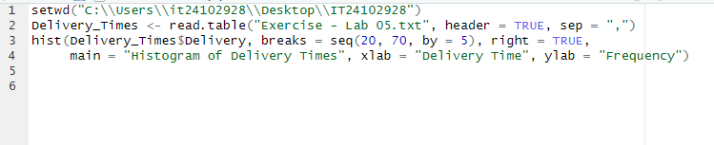

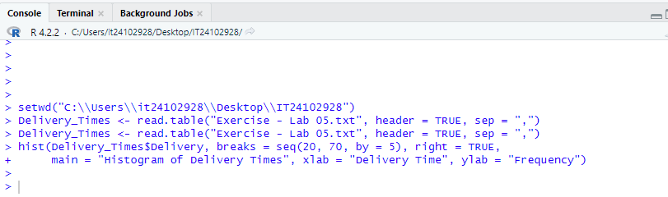

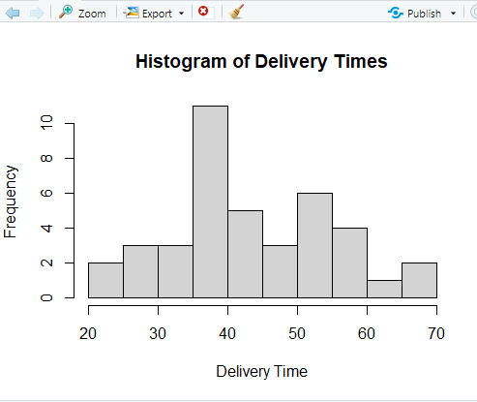

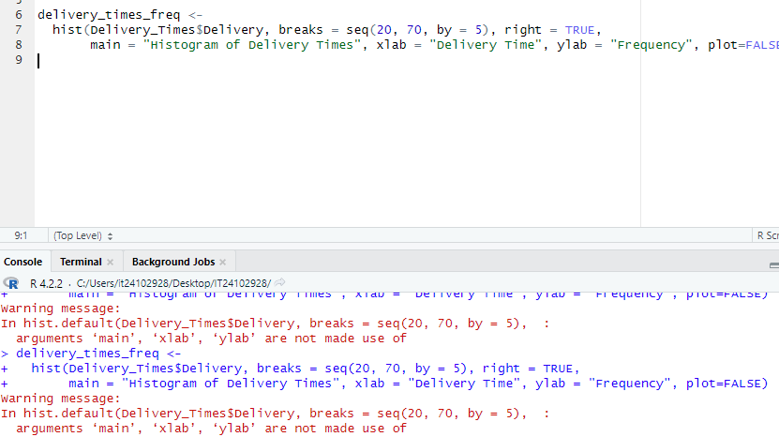

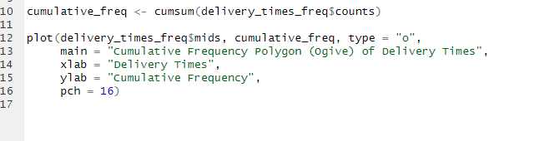

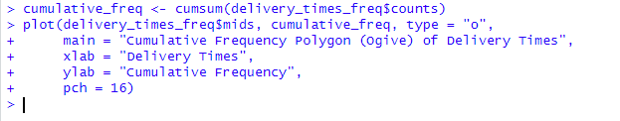

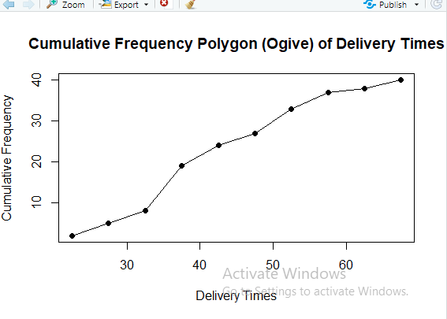

**03) The data shows a single peak around 35-40 minutes and is skewed to the right.**